Yale University
Econ 131 – Econometrics and Data Analysis
Fall 2013
Stata Tutorial

Outline
- The Windows of Stata
- The Types of Stata Files
- How to Access and Use the Material for the Stata Tutorial

1. The Windows of Stata
When you start Stata, five windows will appear on your screen:
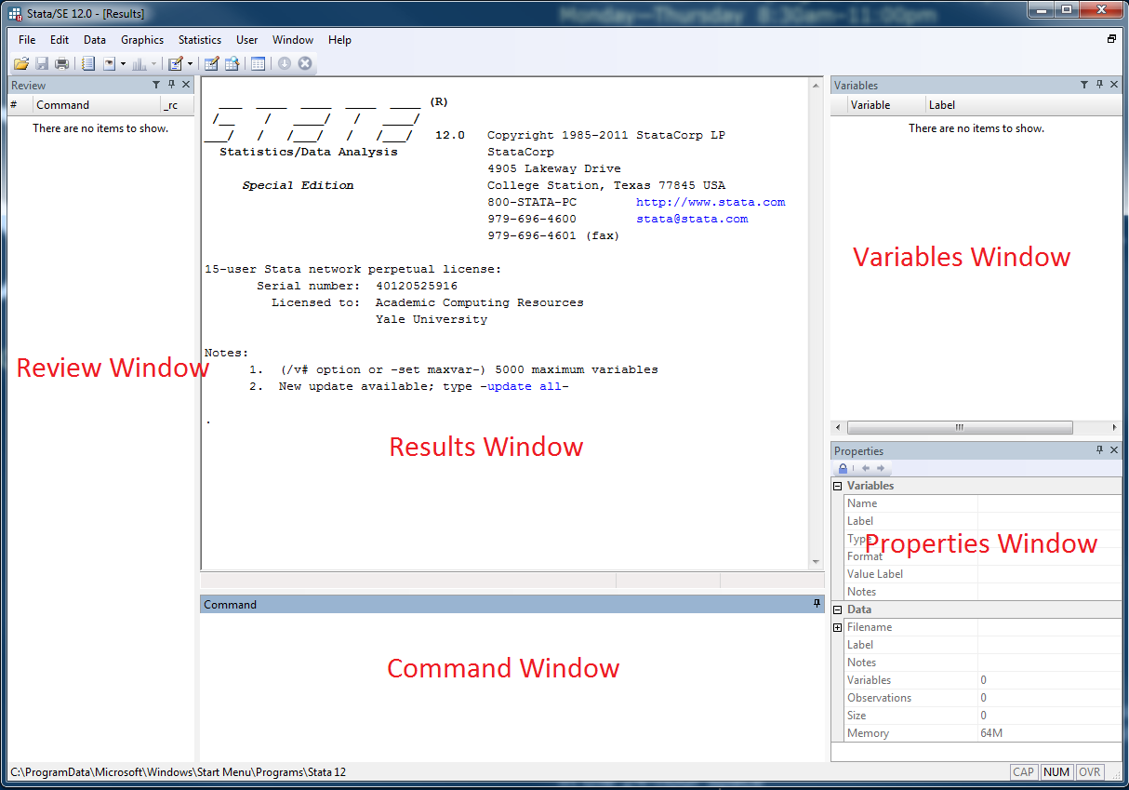
- Command window: The Command window at the bottom of the screen is where you will type in commands. To have Stata execute commands, use the Enter key.
- Results window: The Results window displays the output from commands. The Results window is for screen display only; that is, its contents cannot be edited. However, the output from commands can be directed to and recorded in a log-file.
- Review window: The Review window displays previously entered commands. To re-run commands without typing them again, click the command in the Review window. The command will appear in the Command window; then hit Enter to execute the command. You can also double click commands in the Review window to run them right away. The contents of the Review window may also be saved to a file to edit and to use as a do-file; you can do that by right-clicking in the Review window and select Save All.
- Variables window: The Variables window lists variables in the currently active dataset. Clicking on a variable name in the Variables window will add that variable name into the Command window.
- Properties window: The Properties window displays properties of the currently active dataset (number of observations, size, etc.) and of its variables (variable name, label, type, etc.).
Other Windows are accessible by clicking on the corresponding menu button:
- Data Editor: allows entry or correction of data. Use it cautiously to avoid modifying the data in undesired ways (however, you will be asked to confirm changes upon closing the window).
- Data Browser: allows viewing but not editing of data (it is, thus, safer than the Data Editor);
- Do-File Editor: allows for editing or creating lists of commands in do-files.
Stata provides menu choices and buttons for almost any task, but most users prefer to enter commands in the Command window for most tasks.

2. The Types of Stata Files
There are four main types of Stata files:
- .dta files: these are the files that contain the data in Stata format (when their content is displayed, they look very similar to an Excel spreadsheet);
- .do files: these are .txt files in which you can save your commands, for future reference and editing;
- .log files: these are .txt files which save the output from the Output window, for future editing and printing;
- .gph files: these are image files containing the graphs you create in Stata.

3. How to Access and Use the Material from the Stata Tutorial
The following two files are available on classesv2:
- mexican_family_life_survey_2002.dta;
- econ131_stata_tutorial.do.
The first file contains the actual dataset you are going to use. The data are from the 2002 Mexican Family Life Survey. The Mexican Family Life Survey (also known as MxFLS) is a multi-thematic database which collects a wide range of information on socioeconomic indicators, demographics and health indicators on the Mexican population. You are only going to use some of the variables in the MxFLS dataset. If you are interested, you can download the Stata files for the rest of the dataset through the link: http://www.ennvih-mxfls.org/.
The second file contains a description of the type of analysis you can carry out using Stata, together with the specific commands you can use for specific tasks. It guides you through:
- How to get data into Stata;
- How to inspect the data;
- How to analyze the data through descriptive statistics;
- How to modify the data;
- How to create graphs;
- How to get help.
The description of how Stata works is presented in a do-file to make you familiarize with how do-files work. The use of do-files is highly recommended, as they allow you to have all the commands you wish to use in a single file, and help you keep track of your work.
Here are the steps you should follow to access and use the material:
- Download from classesv2 the two files on a computer on which Stata is installed;
- Start Stata;
- Open the Do-File Editor by clicking on its icon in the menu;
- In the Do-File Editor, use File>Open to open the do-file econ131_stata_tutorial.do.
- Follow the steps in the do-file to practice the material. To run a command contained in a do-file, highlight it by clicking on the left of the corresponding line and then click on the “Execute Selection” icon in the menu.

